Name:
Class:

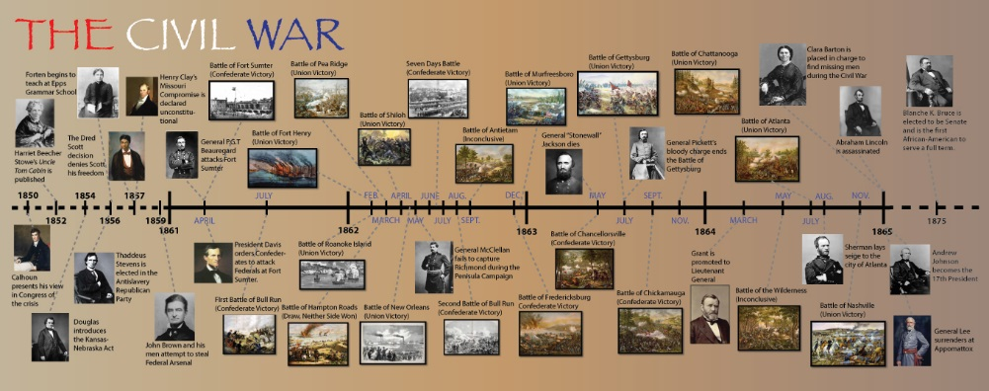

Civil War Timeline Project Due: Wednesday, April 5, 2017
Project description: Sectionalism, states’ rights and slavery broke the United States apart. You will research the specific causes, important events during the war, and the reconstruction efforts as a result of the Civil War. Your timeline must have a creative theme which is depicted throughout the project. Your timeline must include the following:
- 6 pre-Civil War events (before 1861)
- 8 events during the Civil War
- 4 events after the Civil War – Reconstruction
Every item on the timeline must depict your theme. In addition, each item should include:
- Proper name of the event
- Names of important people involved in the event
- Accurate and specific date/s of the event
- Result or outcome of the event
- Image or picture depicting event with citation of source of picture

Grading Rubric:
Earned points
- 18 entries x 5 points each = 90 ________
- Theme for timeline 10 ________
- TOTAL = 100 ________

TEKS: 8.8abc
IB Category A: Knowledge

