Civil War Scrapbook Project
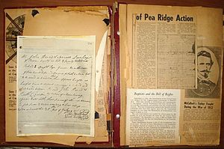
Name:
Class:
Due: Wednesday, April 5, 2017

Project description: Sectionalism, slavery and states’ rights broke the United States apart. You will research the specific causes, important events during the war, and the reconstruction efforts as a result of the Civil War. Your scrapbook must depict a chosen perspective, include artifacts, and appropriate citations.
- First, decide your perspective and choose your role: civilian, politician, soldier
- Second, choose your side: Union or Confederacy
- Every entry will be from the perspective of your chosen role and side.
You will include eighteen items such as maps, diary entries, pictures, letters, tickets etc. The artifacts must be in your scrapbook in chronological order and express the significance of your event. You MUST have artifacts related to the following:
- 6 pre-Civil War events (before 1861)
- 8 events during the Civil War (1861 – 1865)
- 4 events after the Civil War – Reconstruction (1865 – 1877)
You must use primary sources, images, letters, journal entries and factual descriptions for EACH entry. A primary source or artifact is a letter, journal entry, poster or image which is perceived to be from the time period or era. You may write your own letters or use ones found in your research. You must cite all your sources in your bibliography using the correct format.
Grading Rubric:
Earned points
- 18 scrapbook entries x 5 points each = 90 ____________
- Creativity of scrapbook/diary cover = 5 ____________
- Bibliography = 5 ____________
- TOTAL = 100 ____________

TEKS: 8.8abc
IB Category A: Knowledge

