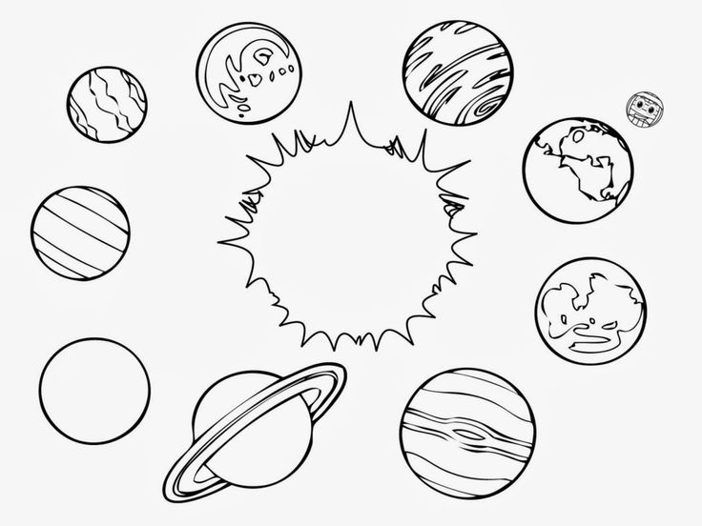
5th 6 Weeks Project- “our Solar System”
Purpose: Many students have a good concept of the relative sizes and compositions of the planets and moons. They have seen many scale models of the planets and have been exposed to various data concerning the planet’s or moon’s characteristics. But, have you ever wondered WHY the planets have the characteristics that they do? This project sets out to allow students the opportunity to make predictions and answer questions surrounding the origins of the planets and moons and how they developed their varying characteristics.
Task: Create an interactive poster to explain the origins of planets and moons, their defining characteristics, and make predictions about how these solar bodies could be influenced by solar weather or changes to their normal patterns.
MY SOLAR BODY: _______________________________
Date assigned: FRIDAY, FEBRUARY 10.
DUE DATE IS FRIDAY, MARCH 10, 2017- NO EXCEPTIONS.
Requirements: Your project must contain the following:
___ COLOR picture of the solar body
___ 2 QR links to video about the solar body
___ All numerical information in km (kilometers), kg (kilograms), K (kelvin)
___ All information cut out and neatly GLUED (NO TAPE) on poster board- size= 22in. x 28in.
___ ALL INFORMATION TYPED- no handwriting should be on the poster unless for visual aesthetics (ie- “artsy” title or section headings)
___ SHORT ANSWER QUESTION TYPED and glued on back of poster
___ At least 4 BOOK sources*
___ At least 1 encyclopedia source (book or online)*
___ At least 1 online journal or article source*
___ Bibliography typed, APA format, and glued to back of poster
___ Name and class period TYPED and GLUED to BACK of poster
*use the Library webpage to access online resources and information about the project
http://jllonglibrary.weebly.com/planets-and-moons.html
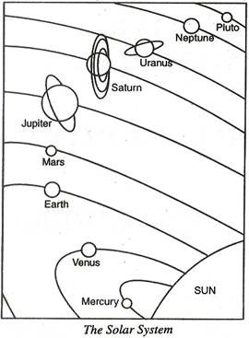
What information do I need on my poster?
- Equatorial diameter (labeled on a diagram)
- Polar diameter (labeled on a diagram)
- Mass
- Orbital period around the Sun
- Distance from the Sun
- Density
- Temperature (surface, atmospheric, and/or core)
- Natural satellites? (if yes, how many?)
- Rings? (if yes, how many and what are they composed of?)
- Atmospheric composition (listed as a percentage)
- Any trace of water? (if yes, describe it- liquid, ice, plasma, etc)
- Artificial satellites, rovers, or orbiters?
- First flyby- name of shuttle, country, date
- First landing- if applicable, provide name, country, date
- How did it get its name? (mythological theory)
- Where is it located? (use a diagram to label and describe the location)
- What does it look like? (describe the surface)
- What is its composition? (inside/outer layers)
- Significant weather? (if so, describe it)
- Temperatures
- Data table comparing to the length of day/year, weights of objects due to changes in gravity- in comparison to Earth
- Describe the orbit and rotation (use a diagram to show this)
- Location in the night sky (provide a picture to show location when viewed from Earth)

Solar Body Specific Questions
Please use the list below to make sure you have answered questions specific to your particular solar body. Only answer the question(s) for your solar body. These questions can be answered on the front of your poster in one of your grouped sections, or you could make a separate section, or you could incorporate the information into one of the QR interactive links to a video/diagram/interactive that YOU produce. These must be answered in a complete sentence. You NEED to include the question when you answer it!
- Mercury- Why are there so many craters on the surface?
- Venus- What is the surface like? Describe the “continent” like features and volcanic activity
- Mars- Describe the surface features of the north and south. Describe the seasons and explain why scientists believe they have discovered evidence of rivers on Mars’ surface.
- Jupiter- Describe the surface, list the Galilean moons and explain why the moons are named as such
- Saturn- What makes the rings “disappear?”
- Uranus- What is unique about the axis and moons?
- Neptune- What is unusual about the moon Triton?
- Pluto- describe why it was once categorized as a dwarf planet/plutoid. Where are most dwarf planets found?
- Sun- describe how some of the solar activities affect us here on Earth. Have at least 2 supporting occurrences.
- Ceres- what makes this a dwarf planet as opposed to just a simple asteroid?
- Io- Describe the unique characteristic of this moon (heating capability).
- Europa- what is the cause of its “cracked” appearance.
- Ganymede- Describe evidence of plate tectonic activity and meteor impacts.

Short Answer Question- EVERYONE MUST ANSWER THIS QUESTION. Your response should be typed and glued to the back of your poster.

Describe how the characteristics of your solar body might change if affected by solar weather.
*Give specific examples of solar weather, how it could affect specific characteristics of your solar body, and make a prediction about the changes that could occur to the surface, magnetism, atmosphere (if applicable), and composition.

