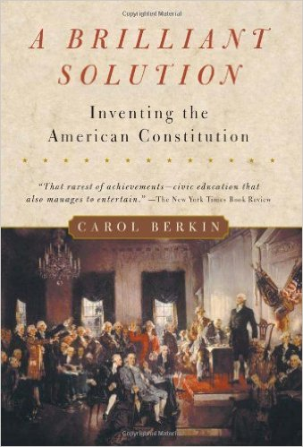
Pre AP US History Summer Reading
A Brilliant Solution: Inventing the American Constitution
By Carol Berkin
Currently available for purchase through Amazon for less than $1, plus shipping, and may be borrowed from the library. If you have problems obtaining it, please let one of us know.
Summary: We love learning about wars, particularly the American Revolution, from the Declaration of Independence to Cornwallis's defeat. However, our first government structure, The Articles of Confederation, was a disaster. This crisis caused a group of men to journey to Philadelphia in 1787 to create a more stable government. The framers, some famous and others just ordinary men, had no great expectations for the document they were designing. Somehow, in the mixture of ideas, argument, and compromise, a great thing happened: A constitution and a form of government were created that have served us for over 200 years. The author tells the story of that amazing summer in Philadelphia as if you were in the room. You listen to the arguments, get to know the framers, and appreciate the difficult and critical decisions being made.

Your summer assignment is to read the introduction and first four chapters, pages 1-95, and annotate the text. It is critical that you understand the content. Annotation is the most efficient way to build comprehension.
If you have never heard of the Constitutional Convention, we suggest you view the following video to gain an initial understanding of the event:
http://www.history.com/topics/us-presidents/james-madison/videos/america-gets-a-constitution
We look forward to working with you next year!
Your 8th grade US History teachers,
Leslie Kennon, lkennon@dallasisd.org
Karen Morrissey, kmorrissey@dallasisd.org
Karen Zotos, kzotos@dallasisd.org

Guidelines for Annotation
Critical Thinking and Active Reading Demonstration:
- Full range of “meaning-making” strategies used consistently, which include connect, reflect, evaluate, compare/contrast, inquire, predict, apply, conclude, summarize or restatement.
- A thread, connecting the annotations, that creates a unified structure to the interpretation of meaning.
- More than one thread exists, so that multiple meanings begin to emerge.
- Annotations reflect logical, strong support for the interpretations, reflections and evaluations, and/or ask reflective questions.
- Annotations are of the necessary depth/length so that the reasoning is clear to the reader.
We recommend that you read about 10 pages per day. Highlight or underline ALL key terms, meaningful quotes, and important concepts. Summarize, rephrase or document a wondering about every highlighted or underlined word/phrase/sentence. This is how you develop themes and connections.
Every paragraph will have something important to annotate.

Rubric Categories | 5  Thorough and insightful | 4  Acceptable and literal | 3  Attempted and Gaps | 2  Partial and incomplete | 1  Confused and inaccurate
Number of Annotations | Ample margin notes | Sufficient margin notes | Some margin notes | Few margin notes | Very few margin notes
Quality of Annotations | Insightful margin notes with many connections made beyond the text; outstanding effort | Literal margin notes show understanding of the text; sufficient effort | Some margin notes show confusion; some effort | Many margin notes show confusion; little effort | Most margin notes show confusion or inaccuracies; very little effort
Quality of Writing | Very neat writing; very easy to read | Neat writing; readable | Attempted to write neatly; some areas require effort to read | Struggled to write neatly; many areas require effort to read | Really struggled to write neatly; most areas are difficult to read
Illegible or inaccurate annotations score a 0.

